How Malapportioned is the Electoral College?
A Multiple Indicators Historical Perspective: 1790-2016

ABSTRACT

We examine the claim that the U.S. Electoral College (EC) is very badly malapportioned, and we consider present levels of malapportionment in historical perspective using apportionment data going back to the Founding. We show that the common wisdom about the extent of malapportionment in the EC is exaggerated once we distinguish between large differences in population share and EC vote share between the most under represented and the most overrepresented state, since the states with the greatest malapportionment do not make up a large share of the EC vote. Indeed, while malapportionment in the EC must be larger than malapportionment in the U.S. House, it is not that much larger, and the EC is far less malapportioned than the U.S. Senate. JONATHAN CAN YOU PROVIDE THESE COMPARISONS FOR ALL THE MEASURES WE USE? Moreover, when we measure malapportionment using the metrics that are most common is the electoral systems literature to measure seats-votes disproportionality (Loosemore and Hanby, 1971; Gallagher 1991), we find the EC in population terms looks remarkably proportional. Similarly, when we compare the Gini value of EC seat allocations to Gini inequalities in incomes in the U.S. across states, JONATHAN CAN YOU PROVIDE THis COMPARISON? we find the former miniscule compared to the latter. Finally, we show that contemporary levels of malapportionment are below historical levels, returning to levels not seen since the mid 19th century.

Word Count: 6391

Keywords: Malapportionment, Electoral College, Gallagher Index, Gini Index, Elections, Representation, Voting
I. Introduction
Malapportionment bias is often regarded as inherently normatively undesirable. Malapportionment leads to a violation of “one person, one vote”, regarded by many, including one of the leading 20th century students of democracy, Robert M. Dahl, as a necessary condition of democratic governance from a democratic theory point of view (Dahl 1971). Similarly, leading specialists in electoral systems, such as Taagepera and Shugart (1989), consider malapportionment as a pathology. While there are both proponents and opponents of the U.S. Electoral College (EC), and many different arguments pro and con its continued use, given the overweighting of small states induced by the two seat federal bonus, it would seem that there can be little dispute that the Electoral College is badly malapportioned. Here we offer analyses intended to challenge this common claim. some of the early footnots???!!
Using a variety of different metrics, we show that apportionment equality in the EC at the state level looks far more like apportionment equality for the U.S. House of Representatives than it looks like apportionment inequality in the U.S. Senate .JONATHAN I CAN’T FIGURE OUT WHAT HAPPENED TO the intermediate footnotes???!! JONATHAN THIS IS HOW I WOULD NOW LIKE US TO START OFF THE PAPER.with ec vs House vs Senate comparisons We then show that, nonetheless, those who think the Electoral College is badly malapportioned will be found to be correct if we judge malapportionment by the usual metrics used to judge compliance with “one person, one vote” in contemporary U.S. voting rights law, but only because the U.S, House, viewed nationally and not state by state, is malapportioned by these same measures. In contrast, other metrics lead to a very different conclusion. In particular, when we evaluate EC malapportionment using the two metric that areis st common is the electoral systems literature to measure seats-votes disproportionality, namely the Gallagher iInex (Gallagher, 1991), ad the Loosemore-Hanby Index (Loosemore and Hanby, 1971), this analysis leads us to the conclusion that the EC behaves with respect to seats to population comparisons much like a proportional representation system does with respect to seats to votes comparisons. Similarly, Gini-index based measures of EC malapportionment suggest little bias, at least as compared to the vast discrepancies we observe when we look at income distributions. JONATHAN THINK ABOUT WORDING
There are three reasons why EC malapportionment effects are commonly overstated. The first is the confusion between population based malapportionment and seats-cotes disproportionality. To understand Electoral College effects, we need to distinguish the mechanical effects of the Electoral College that we may think of as “malapportionment related” (i.e., due to discrepancies between a state’s EC vote share and the state’s population), which arise simply because EC vote allocations equal the size of a state’s U.S. House delegation plus the size of the state’s U.S. Senate delegation, from effects that are tied to the distribution of the votes across states in each election. The former applies throughout any given redistricting decade; the latter are election specific. It is only the decade specific population-based malapportionment that we will consider in this article.
The second is the distinction between malapportionment measures that are based on the population discrepancies between the largest and smallest units and those based on some weighted average discrepancy that takes into account the relative size of the units.
The third is the recognition that, while malapportionment is often blamed for
for causing the divergence between popular and EC vote),"JNATHAN I CAN’T FIGURE OUT WHAT HAPPENED TO the intermediate footnotes???!! that is far too simplistic a diagnosis. Many factors affect this divergence, most importantly the partisan bias in the distribution of vote shares across states. Eidence on this bias suggests that it has sometimes favored Democrats and sometimes favored Republicans (Grofman, Koetzle and Brunell 1997; .Patti and Johnson 2014). Moreover, th analyses we present below enable us to demonstrate that the discrepancy between popular vote outcome and EC outcome that occurred in 2000 and 2016 cannot be blamed on an increasing EC malapportionment in recent decades, since contemporary levels of EC malapportionment are, by virtually all measures, below historical levels, returning to levels not seen since the mid 19th century.

II. Measures of Disproportionality Between State EC College Vote Share and Population Share

As noted earlier, we wish to measure “malapportionment bias” in the Electoral College in a way that does not depend upon the actual distribution of votes in any given election. Below, we offer six different indicators of the way in which there is a disproportionality between a state’s EC vote share and its population share.. We calculate three types of malapportionment indices:.oOn set of measures is based on discrepancies between the two states exhibiting, respectively, the greatest and the least discrepancy between population share and EC vote share;. anoher type is based on average or total discrepancy measures, such as those used to measure disproportionality in seats-votes relationship, though for one of these, the Loosemore-Hanby Index, for space reasons, the full data is reported only in the Appendix. ; tTh tird type is based on measures such as the Gini index that look in some fashion at the entire distribution of discrepancies.,though for one such approach, looking at the smallest population sufficient to produce and Electoral College majority, for space reasons, we provide full data only in an appendix.
We show that it is only the first type of measure that leads to a conclusion that malapportionment effects in the EC are very large, and that even this claim must be modified once we recognize that, at the national level, looking across states, the EC level of malapportionment is not much different from that in the U.S. House of Representatives and quite different from that in the U.S. Senate. Moreover, once we look instead at a population-weighted average malapportionment bias, or at measures that look at the whole distribution of discrepancies, since the states with the greatest malapportionment do not make up a large population share, we arrive at quite different conclusions about the extent of malapportionment bias in the EC.

(1) Measures based on highest and lowest disproportionalities
One measure of potential malapportionment effects is to look at the discrepancy between Electoral College allocations and state population in a way that is directly analogous to the method that courts (and expert witnesses) in one person, one vote cases in the U.S. use to measure malapportionment within a state. The standard way to measure compliance with a “one person, one vote” standard is to examine the total population deviation for a state’s legislative (or congressional) districts. The formula for calculating the total population deviation is

TOTAL POP DEV = (1)

which can be rewritten as

TOTAL POP DEV =


An alternative approach would be to simply report the ratio of the largest congressional district to the smallest district.
MAX/MIN = (2)

However, since we are interested in malapportionment across states rather than within states, and because we are dealing with a weighted voting rule where states may vary in the number of EC seats they receive, we will do both comparisons in terms of the ratio of state population share of total population to state Electoral College vote share of the total EC vote, i.e., in terms of the number of people in the state per Electoral College vote in the state. JONATHAN, DELETE THE MATERIal IN RED. I JUST REALIZED THAT I HAVE DONE THESE RATIOS BACKWARDS!!!! THEY SHOULD BE IN TERMS OF the ratio of state Electoral College vote share of the total EC vote (denoted ecvotes_{i}) to the state population share of total population (denoted pop_{i}), which we may think of as its appropriate OPOV-based seat share JONATHAN I JUST REALIZED THAT in doing THESE RATIOS BACKWARDS, to redo them right you will (a) have to change BOTH the formulas below appropriately by inverting EC and pop !!!! and (b) you will need to redo algs 1 and 2 figuresingly.

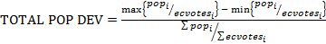 (1)’

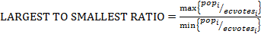 (2)’

The EC version of the ratio measure and the EC version of the total population deviation measure are reported in Figures 1 and 2, respectively. JONATHAN I CAN’T FIGURE OUT WHAT HAPPENED TO the intermediate footnote???!! For comparison purposes, Figures 1 and 2 also show the same type of malapportionment calculations I the U.S. Senate, on the one hand, and for the U.S. House, on the other, using a state based composite measure for the House that is the ratio of House members allocated to the state to the total size of the House. JONATHAN YOU WILL NEED TO PROVIE THESE. using the corrected formulae. WHAT I THINK THEY WILL SHOW IS THAT THE EC IS INTERMEDIATE BETWEEN THE HOUSE AND THE SENATE, BUT IS much much closer to the House than to the Senate. While we may think of the U.S. house, post Baker v Carr (1962) and Wesberry v. Sanders, (1963) as having virtually no malappportionment, that is true only if we look within states. Across states the method of apportionment in the House can generate malapportionment (see e.g., Ladewig and Jasinski, 2008; Edelman 2015), due to the fact that each state, no matter what its population, is guaranteed at least one seat in the House of Representatives, and the fact that there are rounding issues (the so-called integer allocation problem: Balinski and Young, 1982).
<Figures 1 and 2 about here>>

Table 1: Measure of Discrepancy between Largest and Smallest Average Electoral Populations

Figure 1: Ratio of the Largest and the Smallest State by EC Seat Share versus State Population Share: 1790-2010, with Comparisons to the U.S. House and the U.S. Senate JONATHAN YOU WILL NEED TO PROVIDE THE NEW FIGURE FOR THE REVISED FORMULA AND ALSO THE comparable DATA FOR THE House and the DATA FOR THE SENATE
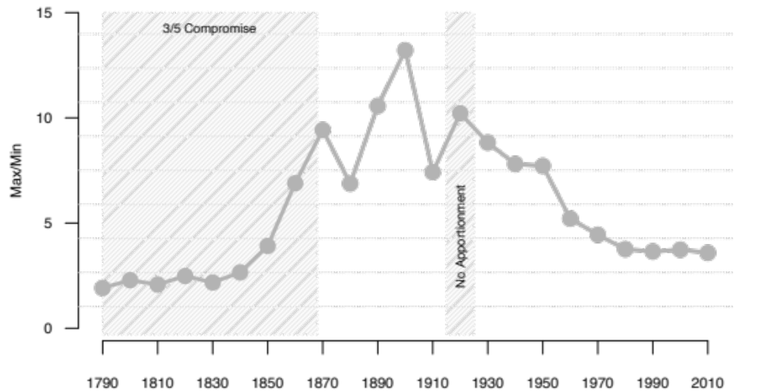

Figure 2: Total Population Deviation for Electoral College Votes, 1790-2010, with Comparisons to the U.S. House and the U.S. Senate JONATHAN YOU WILL NEED TO PROVIDE THE NEW FIGURE FOR THE REVISED FORMULA AND ALSO THE comparable DATA FOR THE House and the DATA FOR THE SENATE

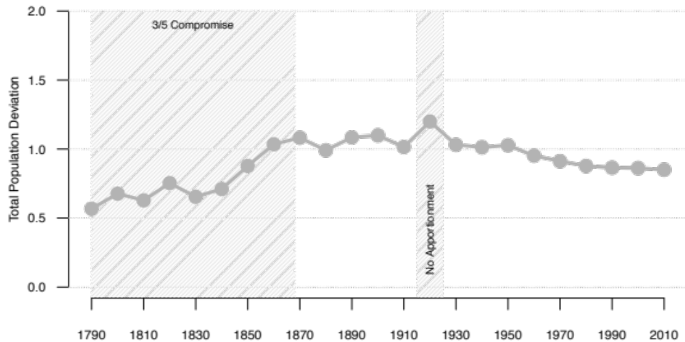

Since both measures focus on the same two states, the two EC disproportionality measures defined above are quite highly correlated, with a correlation of 0.90 JONATHAN PLEASE CORRECT this number WHEN WE HAVE THE NEW FORMULAE. However, when we compare Figures 1 and 2, EC Total Population Deviation appears to show a more muted effect, because we are directly taking ideal population into account. But both Figures 1 and 2 reinforce our claim that EC malapportionment is closer to low levels of House malapportionment than it is to the high levels of Senate malapportionment. JONATHAN THINK ABOUT WORDING WHEN WE HAVE THE REAL FIGURES.
The degree of malapportionment we expect to see in these two measures is affected by the size of the smallest state, since in all but the 1790, 1830, and 1850 decades of redistricting it was the smallest state which was the most overrepresented. Moreover, both measures --either explicitly, for the total population deviation measure, or implicitly, for the ratio measure – are affected by ideal population size. Thus, these malapportionment measures are also affected by the size of the House. We will have more to say about House size effects later in the essay.

(2) Measures based on overall or average disproportionalities
The next two measures we present offer different ways to portray how lack of a perfect fits between population share and EC vote share might generate discrepancies between popular vote and EC vote outcomes. These measures all consider disproportionalities between EC share and population share in all states, not just the two states that are the furthest away from population share based allocations. These measures are, however, still a priori ones in which we do not consider the actual votes in any election as these were distributed across the states. By again tracking each of these measures over time, we can see the a priori extent of potential malapportionment-induced bias. JONATHAN I CAN’T FIGURE OUT WHAT HAPPENED TO the intermediate footnotes???!!
The Loosemore-Hanby index (Loosemore and Hanby, 1971) and the Gallagher index (Gallagher, 1991) have long been used to show the disproportionality between the cumulative share of votes a party gets for all its candidates and the seat share that the party receives. Loosemore-Hanby measures the summed absolute differences between seats and votes, while Gallagher’s index, often referred to as a Least Squares measure, weights each observation by the size of the deviation, i.e., it squares the deviations -- doing so puts more weight on larger deviations, while discounting smaller ones.
In the Electoral College context, the Loosemore-Hanby index is defined by the equation
(3)
and the Gallagher index is defined by the equation
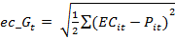 (4)
where EC_{i} is state i’s proportion of the electoral college and P_{i} is a state’s proportion of the total population.
Both indices are constrained to a range between 0 to 1, with values near zero indicating low disproportionality. Here we will report full data in the text only for the Gallager Index, with full data for the Loosemeore-Hanby Index reported in an Appendix and only summary conclusions reported in the text. We expect that average malapportionment will seem much lower in these measures than in the two ways we have previously calculated malapportionment, since the previous measures focus on only the two states with the largest and the smallest discrepancies. In addition to evidence about historical malapportionment in the Electoral College under the Gallagher Index, we provide comparisons in Figure 3 to values of this measure for the House (taking state congressional delegations as our units), and for the U.S. Senate.

<< Figure 3 about here >>

Figure 3: Loosemore-Hanby and Gallagher Indices Index for EC Population Discrepancies, 1790-2010, with Comparisons to the U.S. House and the U.S. Senate
(4) In order to compare the magnitude of disproportionalities in the EC vote generated by House rounding and the rule that all states must have at least one seat in the House with that caused by two seat Senate bonus, we can generate Loosemore-Hanby and Gallagher measures for the disproportionality between a state’s population share and its share of House seats.
(5)
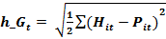 (6)
ere _{i}i c ppodecade andH e earlier measures as EC weighted measures and the present measures as HseWe show in Figure 3 the comparison between the EC disproportionality time series for the Gallagher measure, and, for comparison purposes the same type of data for the Gallagher measure of House disproportionality and of Senate disproportionality.
here >>

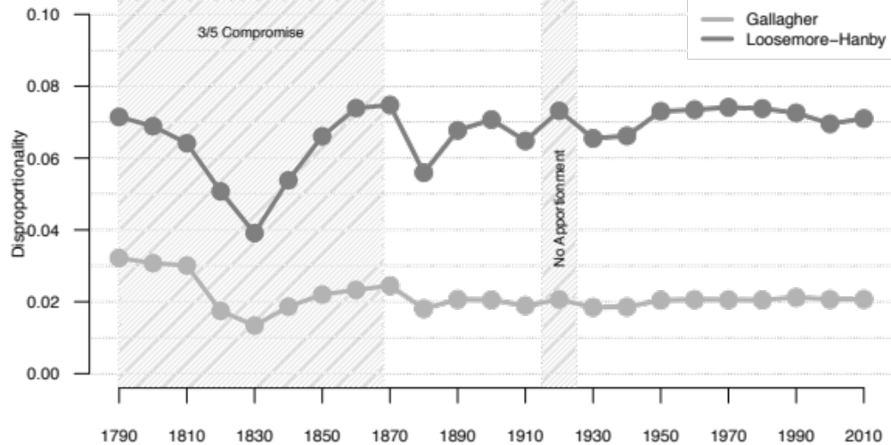

Loosemore-Hanby is sensitive to small deviations between population share and EC share, whereas the Gallagher measure weights small deviations less than it would large deviations, since it is squaring the size of deviations. Nonetheless, both measures are remarkably flat in the post-Baker v. Carr era. Malapportionment as judged by the Gallagher Index and by the Loosemore-Hanby Index is closer to malapportionment for the House than it is to malapportionment for the Senate (for Loosemore-Hanby data see Appendix).

(3) Other Measures based on the total distribution of discrepancies

. thdiHAN THS

:

A Gini Index measure of a priori inequity in apportionment based on a Lorenz curve, parallels a standard way of looking at inequity in income distribution (see e.g., Bai and Lagunoff, 2013). We would do so by again arranging the states from most underrepresented to most overrepresented in terms of the EC vote to state population ratio and then plotting the cumulative distribution of state EC vote share against the cumulative distribution of the population vote share for those same states to give us a Lorenz curve. We could then measure the area between that curve and the 45-degree perfect equality line (where each states’ EC share equals its population share) so as to calculate the Gini Index for these two cumulative distributions.
We illustrate Lorenz curves for decades separated by a 40-year interval in Figure 6, and we show the full-time series for the Gini index in Figure 4. The Gini Coefficient is calculated using the ineq library package in R. The Gini Coefficient is calculated in the same manner as income inequality would be but using, instead of income, cumulative values of population and EC share. The Gini index varies between zero and one. A value of zero indicates zero disproportionality. As measured by the Gini coefficient, the disproportionality generated by the Electoral College is miniscule, with results from Figure 4 generating Lorenz curves coming close to straight lines, with values around JONATHAN FILL IN. The Gini index for the U.S. House is 2012 was JONATHAN FILL IN; that for the Senate in 2012 was JONATHAN FILL IN. For comparison purposes, the Gini index for income inequality in the U.S. is now close to 0.4. Also, the data series shown in Figure 5 is remarkably flat in recent decades, and actually (trivially) lower in 2010 than in previous decades during the post-Baker v. Carr era.

<<Figure 4 and Figure 5 about here>>

Figure 4: Illustrative Lorenz Curves for the EC 1810, 1850, 1890, 1930, 1970, and 2010
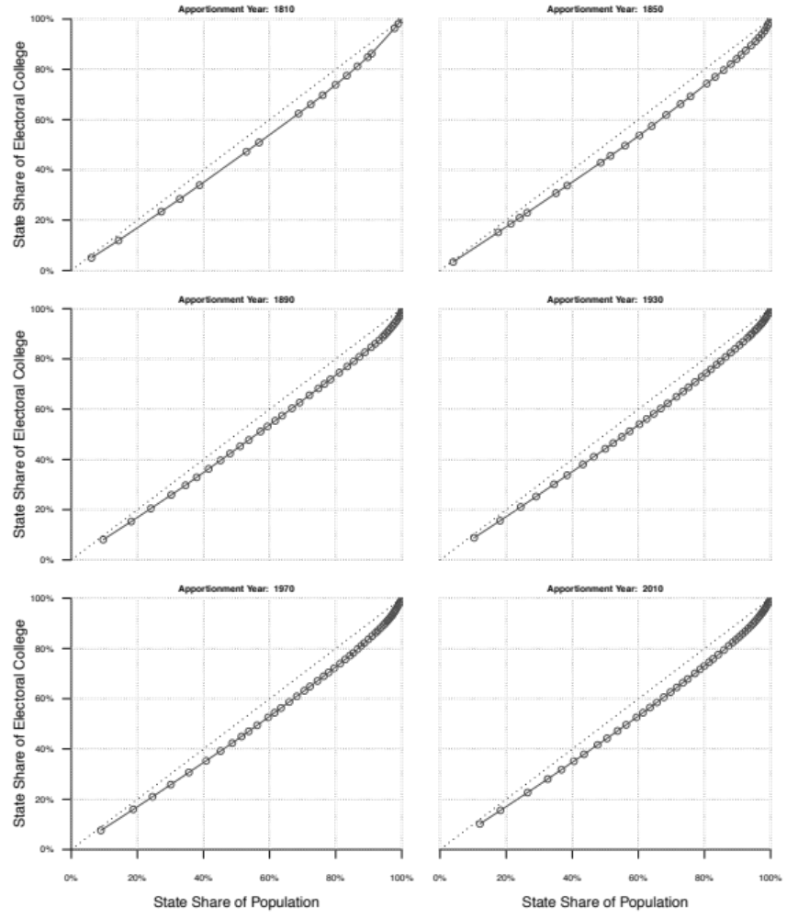

Figure 5: Gini Index Values for the Electoral College: 1790-2010
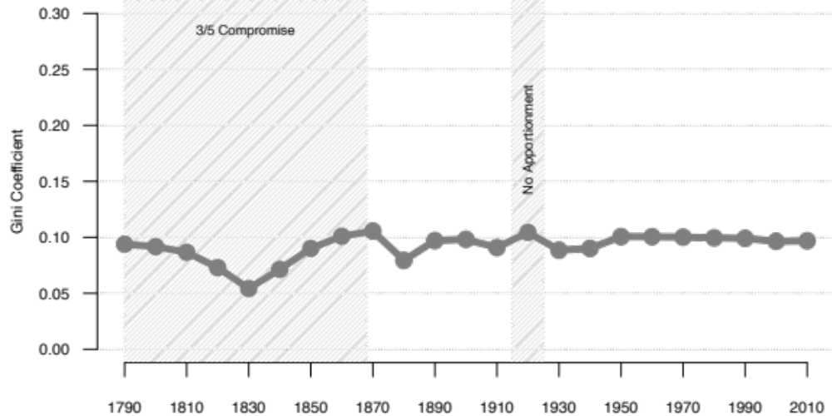

Another way to think about malapportionment and disproportionality is to order the states from smallest in population to largest, adding up Electoral College votes along the way until we reached a majority of Electoral College votes. We then find the proportion of national population that was in that set of states, and use that as a measure of malapportionment. If the EC vote allocations perfectly matched population share, that proportion would be 50%. We show the time series for this measure in Figure xx in the Appendix, only briefly describing the results in the text.
Comparing other measures with this one allows us to isolate two aspects of malapportionment; that which results from the winner take all nature of the Electoral College, and that which derives from deviations from one person, one vote allocations. The latter is better captured in this measure than in our previous ones. JONATHAN CAN YOU EXPAND ON THIS POINT BY EXPLAINING WHY? Here we simply note that again EC results are far closer to those for the House than to those for the Senate. And, also JONATHAN MAYBE FILL IN SOMETHING ELSE. M The solid black line in Figure 4 indicates actual minimum population needed, JNATHAN YOU WILL NEED TO REWRITE OR DELETE THE MATERIAL IN RED d res.
JONATHAN HAVING ALTERNATIVE MEASURES WAS WAS TOO MURKY. JUST REPORT IN THE FIGURE IN THE APPENIX THE ONE MEASURE WE ACTUALLY USE AND DISCUSS THE ALTERNATIVE only IN ATH ATTACHED FOOTNOTE, indicating that data for it available upon request to the senior author. AND

Measures of Disproportionality Between Population and EC Shares and Two Measures of Disproportionality Between Electoral and House-based Allocations

Effects of House size
Unlike most previous work on the EC (Adkins and Kirwan, 2002 is a notable exception), we distinguish between effects of the two sources of malapportionment bias, one based on lumpiness effects in allocating integer numbers of House seats to the states and the requirement that every state have at least one House seat, and the other based on the two seat Electoral College “Senate bonus” given to each state regardless of its population. Loosemore and Hanby index (1971) and the Gallagher index (1991), we are able to distinguish the impacportionment factor foat o nus. We show thmer has benliniespite the freezing of latter has remained flat during that same period.he more substantively important,oth malapptiIn the early period of the U.S., House size increases tended to closely parallel overall population growth, with the House size more than doubling between 1790 and 1837, while the number of states grew from 15 to 26. As is apparent from Figures 1 and 2, in terms of our two measures, these early decades are also the most equitable in terms of EC malapportionment. While the size of the House continued to grow after 1840, its rate of growth failed to match population growth, and new states with initially small populations joined the Union, particularly in the sparsely populated American West, with another twenty-two states admitted between 1840 and 1912 (Ladewig and Jasinski, 2008). Yet, as noted earlier, in 1929, following the Permanent Apportionment Act, the size of the House was fixed at 435. Because the House size was frozen at 435 in 1913, and the number of states has been the same since 1960, we might expect that malapportionment would have grown in recent decades. And yet, this is not what the data in Figures 1 and 2 show. Instead we see declining malapportionment over the period in question.
Indeed, for the EC Max/Min ratio measure, we see from Figure 1 a monotonic decline since 1920, with a peak value in 1900; while for EC total population deviation, we see from Figure 2 that it also has declined in a perfectly monotonic pattern since 1920, with its peak value in 1920. Both measures now have values virtually the same as found in 1850. If we look at House-weighted measures (Figure 4) we see a flat pattern. We wish to explain this counterintuitive result.
To explain this puzzle we need to recognize that population growth patterns strongly affect malapportionment. We can account for the decline or flatness in our various malapportionment measures in recent decades by calling attention to two population growth phenomena. On the one hand, the largest states have grown larger relative to the average state; thus, underrepresentation at the high end has been reduced since the larger states contain more of the total population. On the other side of the coin, the smallest state has grown at roughly the same rate as the mean size of Electoral College seats has grown, so the smallest state is no further away from ideal population equality now than in the recent past, and thus the consequences of overrepresentation of small states is thus reduced or kept essentially constant. These time trends are shown in Figure 6.

<<Figure 6 about here>>
Figure 6: Largest and Smallest State Population, Relative to Mean State Population
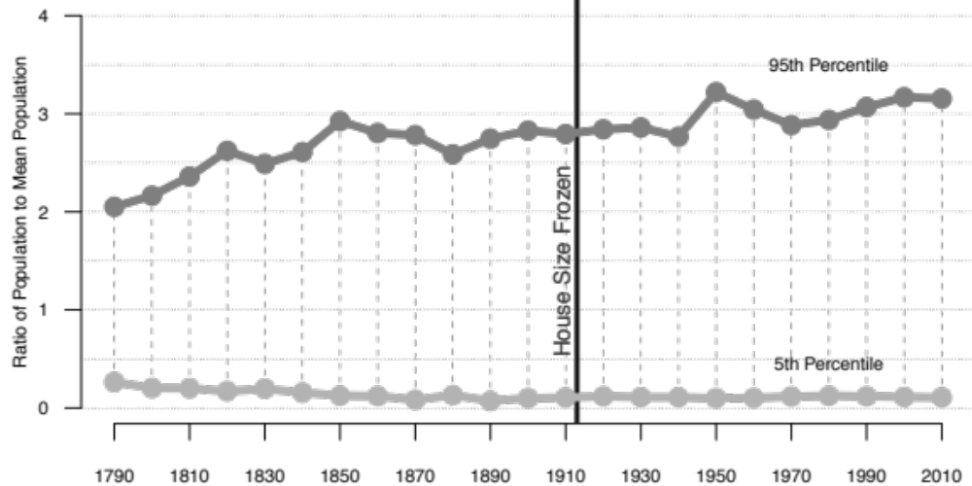

an overall seemingly cohat, in 1790, if we ordeing small state malapportionment bia

III. Discussion

The goal of this essay has been to address the magnitude of Electoral College bias derived from the purely mechanical effects of rules determining the relationship between EC seat share and state population share, i.e., with no attention paid to actual election results.
But how shall we judge whether the exhibited levels of malapportionment are high or low?
First of all, as we saw, for each of the measures we have examined, EC malapportionment is far closer to malapportionment in the House, normally regarded as exhibiting a high level of population equality, than it to malapportionment levels in the U.S. Senate. Samuels and Snyder (2001) offer analysis of malapportionment in a comparative perspective, that shows that malapportionment levels in upper chambers are characteristically much greater than in lower chambers. The Electoral College may be regarded as essentially a mixture between an upper and a lower chamber, but far more closely resembling the latter.
Second, while U.S. Courts have relied on Total Population Deviation, this measure, like that of the ratio of largest to smallest unit, tend to exaggerate the effects of disproportionality because it only on extremes. This measure might be appropriate for measuring intrastate malapportionment, but for the purposes of measuring institutional malapportionment in national governing bodies with varying population totals across states, it can be quite misleading.
Third, the Gallagher measures shows especially low levels of disproportionality. Indeed, the numbers shown in Figure 3, while not as small as the party-based disproportionalities reported for the most highly proportional electoral rules in use world-wide, those of Netherlands and Israel, are comparable to the partisan disproportionalities in other western European democracies. This should not be that surprising, given the small impact a small overrepresented state might have on the total amount of disproportionality in the Electoral College, but it flies in the face of the common wisdom about how badly malapportioned the EC is supposed to be.
Fourth, other approaches to measuring malapportionment that look at the full distribution of population and seats, such as the Gini Index, also reveal very low levels of malapportionment in the EC.
Finally, we have shown that despite the freezing of the House size, and the logical presumption that malapportionment should increase, shifts in the distribution of population across the states has created a situation where malapportionment has returned to low levels last seen in the 19th century, and we have provided an explanation for this unexpected result base on population changes across states of different sizes.

REFERENCES

Adkins, Randall E. and Kent A. Kirwan. 2001-2. “What Role Does the ‘Federalism Bonus’ Play in Presidential Selection?” Publius 32 (4) 71-90.
Baker v. Carr, 369 US 186 1962.
Balinski, M. L. and H. Peyton Young. 1982. Fair Representation: Meeting the Ideal of One Man, One Vote. Yale University Press.
Bullock, Charles III. 2010. Redistricting: The Most Political Activity in America. New York: Rowman and Littlefield.
Cox, Gary W. and Matthew S. Shugart. 1991. “Comment on Gallagher’s ‘Proportionality, Disproportionality, and Electoral Systems’.” Electoral Studies. 10:4, 348-352.
Dahl, Robert A. 1971 Polyarchy: Participation and Opposition. New Haven, Conn.: Yale University Press.
Dong, Xiao, Feng Xu and Shiqiang Zhang. 2014. “A Simple and Practical Method of Calculating the Gini Coefficient.” Progress in Applied Mathematics 8 (1): 29-33.
Döring, H. and Manow, P., 2017. “Is Proportional Representation More Favourable to the Left? Electoral Rules and Their Impact on Elections, Parliaments and the Formation of Cabinets.” British Journal of Political Science, 47:149-164.
Edelman, Paul H. 2015. “Voting power apportionments.” Social Choice Welfare. 44, 911-925.
Gallagher, Michael 1991. "Proportionality, Disproportionality and Electoral Systems". Electoral Studies. 10: 33–51.
Grofman, Bernard, William Koetzle, and Thomas Brunell. 1997. “An Integrated Perspective on the Three Potential Sources for Partisan Bias: Malapportionment, Turnout Differences, and the Geographic Distribution of the Party Vote Shares.” Electoral Studies 16: 4, 457-470.
Johnson, Ron. 2002. “Manipulating maps and winning elections: measuring the impact of malapportionment and gerrymandering.” Political Geography, 21, 1-31.
Karpov, Alexander. 2008. “Measurement of Disproportionality in Proportional Representation Systems.” Mathematical and Computer Modelling 48: (9–100), 1421-1438.
Klarman, Michael J. 2016. Framer’s coup: the making of the United States Constitution. Oxford University Press.
Ladewig, Jeffrey W. and Matthew P. Jasinski. 2008. “On the Causes and Consequences of and Remedies for Interstate Malapportionment of the U.S. House of Representatives. Perspectives on Politics 6:1: 89-107.
Loosemore, John, and Vincent Hanby. 1971. “The Theoretical Limits of Maximum Distortion: Some Analytic Expressions for Electoral Systems.” British Journal of Political Science 1: 467-477.
Monroe, Burt L. 1994. “Disproportionality and Malapportionment: Measuring Electoral Inequity.” Electoral Studies 13, 132–49.
Neubauer, M.G and J. Zeitlin. 2003. “Outcomes of Presidential Elections and the House Size.” PS 36 (4): 721–725.
Pattie, Charles, & Ron Johnson. 2014. “The electors shall meet in their respective states”: Bias and the US Presidential Electoral College, 1960-2012”. Political Geography, 40, 34-45.
Riggs, Jack E., Gerald R. Hobbs, and Todd H Riggs. 2009. “Electoral College Winner’s Advantage.” PS: Political Science and Politics, 42(2), 353-357.
Samuels, David & Richard Snyder. 2001. “The Value of a Vote: Malapportionment in Comparative Perspective.” British Journal of Political Science, Vol. 31, No. 4, pp. 651-671.
Taagepera, Rein and Bernard Grofman. 2003. Mapping the Indices of Seats-Votes Disproportionality and Inter-election Volatility.” Party Politics, 9(6):659-677.
Shugurt, Matthew S. & Rein Taagepera. 2017. Votes from Seats: logical models of electoral systems. Cambridge University Press.
Taagepera, Rein & Matthew S. Shugart. 1989. Seats and Votes: The Effects and Determinants of Electoral Systems. Yale University Press.

Cf. Edwards (JONATHAN FILL IN HERE AND IN REFS) and Ross ( JONATHAN FILL IN HERE AND IN REFS )
Morevor, the method of apportionment itself can generate malapportionment relative to population. (Edelman 2015). The Even representation in the House of Representatives is not perfectly proportional to population when we look across states rather than within-states, and this disproportionality as also affects malapportionment bias in the Electoral College, even though this effect is not as important as the two state bonus. Each state, no matter what its population, is guaranteed at least one seat in the House of Representatives (Ladewig and Jasinski, 2008. And, there are rounding issues (the so-called integer allocation problem: Balinski and Young, 1982).
Including the 2016 election, the Electoral College and the popular vote have now diverged in two of the past five elections. There are many other complaints about the Electoral College, including the observation that the exaggerated swing ratio in the EC leads to EC seat shares that distort the level of support for the EC winner even when the popular vote winner and the EC winner coincide (Johnson, 2002, Riggs et al. 2009, Pattie and Johnson 2014) . In a September 13th, 2017 interview with CNN’s Anderson Cooper, Hillary Clinton, the losing candidate in 2016, said "I think [the Electoral College] needs to be eliminated.
ndithe parti dibutio consider turnout differences among the states.e of the House itself might hain (2003) point out, but given the magnitude of Trumpctory, tuld have to haveb
In addition to the partisan distribution of voters across states, we would also wish to consider turnout differences among the states. Additionally, in 2000, as Neubauer and Zeitlin (2003) point out, the size of the House itself might have affected the outcome, but given the magnitude of Trump’s EC victory, the House size would have to have been increased toward infinity to switch the outcome. Considering the relative importance of different reasons for EC and popular vote discrepancies is beyond the scope of this study.,
See e.g., Wesberry v. Sanders 376 U.S. 1 (1964)
For total population deviation, the worst case occurs with all states having virtually identical populations, but with only the largest of the N states getting any seats. Of course, the actual Electoral College rules we use prevent such a worst case scenario. In particular, given present rules, with 51 states each of which gets a minimum of three Electoral College seats, the worst case scenario has a total population deviation of 538/388= 1.39, which occurs when virtually all population is concentrated in a single state. JONATHAN WITH THE FORMULA CHANGED YOU WILL NEED TO CHANGE THIS FOOTNOTE.
As long as total population can continue to grow, both measures of malapportionment are essentially unbounded. JONATHAN PLEASE DOUBLECHECK FOR THE REVISED MEASURE
The second, and much more major, source of EC malapportionment bias arises because of the two seat “bonus” that comes about because every state gets two U.S. Senators. The smallest states are overrepresented in the EC relative to their population. According to Klarman (2016: pAGE CITATION NEEDED) “malapportionment in the Electoral College … never had a very good justification,” but that view is not held by all scholars who study the constitutional founding.
When another state is roughly the same size as the smallest state peculiarities of the rounding process lead to overrepresentation of the larger of the two states. For instance, in 1790, Delaware had only a slightly lower population than Rhode Island, but due to the rounding formula used in apportionment, Rhode Island had one more congressional seat and thus one additional Electoral College vote, and was more overrepresented in the Electoral College than Delaware, even though Delaware was the smallest state at the time. After 1810 (except in 1830 and 1850), New York had the largest population but the state with the largest population often was not the most underrepresented in the EC relative to population because of the same type of rounding complication. This happened in 1800, 1810, 1820, 1830, 1840, 1850, 1860, 1880, 1920, and 1950, while in 1960 there were two states that were more underrepresented than New York. California surpassed New York as the largest state in 1970, but in 1970 it was not the most underrepresented state.
We deliberately use the term ‘potential’ bias because, in any given election year, the observed partisan bias attributable to malapportionment will depend upon the actual distribution of votes across the states,
For further justification of these measures, see e.g. Taagepera and Grofman (2003).
We also checked these calculations in two ways. First, we calculated the Gini index by using a piecewise linear approximation and then finding and summing the area under the resultant triangles and rectangles. Second, we made use of an approximation formula that was independently proposed by one of the present authors but which yields results that are closely related to the work of Dong et al. (2014). That approximation method posits that the relationship between cumulative EC vote share and cumulative population share is given by cumulative EC vote share = (cumulative population share) raised to the a^{th} power, where a is expected to be a number above 1. To estimate a, we take logs to obtain ln(cumulative EC vote share) = a * ln(cumulative population share) and run a simple OLS, but forcing the line to have a zero intercept. When we use the value of a so obtained and, for that value of a, take the definite integral between zero and one of the original formula, we find the area under the curve as 1/(a+1), so that the Gini index becomes 2 *[½ - 1/(a+1)] where the ½ is the area of the triangle specified by the forty-five degree line and the axes, and the two is a normalizing factor to insure that the index runs between zero and one. The correlation among these various approximations is very high, and they yield nearly identical Gini values.
(http://iresearch.worldbank.org/PovcalNet/povOnDemand.aspx). Of course, we do not have the same expectations (or moral judgments) about income inequality as we do about representational inequality because democratic theory requires our political institutions to promote equality but capitalist institutions do not give rise to the same expectations of equality.
If we divide this number by two, this gives us, in effect, the minimum proportion of the U.S. population sufficient to control a majority of Electoral College seats. Some scholars who marshalled evidence for the unfairness of redistricting practices in state legislatures in the periods before and just after Baker v. Carr made use of analogous measures (see Table 2.1 in Bullock, 2010: 30-31, which reports various estimates of legislative disproportionality that are contemporaneous with Baker v. Carr).
⁴⁰ However, the we are adding integer numbers of Electoral College votes, and adding the single state needed to create a population majority may yield a population sum above 50%.
inimum proportion of the U.S. population sufficient to control aty of Ees described above (see Table 2.1 in Bullock, 2010: 30-31, which reports various estimates of legislative disproportionality that are contemporaneous with Baker v. Carr).
There is an alternative way to calculate the minimum population needed to control a majority of EC votes, namely one where we order states not by population but by degree of overrepresentation relative to population, from most overrepresented to least overrepresented. These two measures need not coincide, nor is it always the case that one provides a higher estimate of minimum population than the other. It’s not always true that ordering the states in this way gives the minimum population needed to reach a majority in the EC. Consider 1830: the minimum reported in the Appendix for that year is 50.9%, but the lowest possible minimum population is 47.5%, which can be obtained by including in the minimum winning coalition North Carolina and excluding Kentucky, even though the latter has a larger population than the former by over 20,000. Considering this rather technical complication takes us into issues peripheral to this essay.
In the 1840 reapportionment, the House size was reduced for the only time in U.S. history, from 240 to 223. It grew again throughout that decade as new states were added. See data and charts in Ladewig and Jasinski (2010).
Temporary increases in House size to 437 occurred in 1959 with the admission of Hawaii and Alaska.
Set by Public Law 62-5 on August 8, 1911 and taking effect in 1913.
When Alaska and Hawaii became the 49th and 50th states, and Washington D.C. was extended the franchise by way of the Twenty-Third Amendment in 1961.
If the populations of the various states are fixed, if House size grows, then malapportionment due to House rounding effects should decrease (Ladewig and Jasinski, 2008). See later discussion of House size effects.
Of our six measures, only the index discussed in the Appendix that calculates the minimum proportion of the population need to secure an Electoral College majority (Belenky, 2005), shows any evidence of a 1929 effect, and even that measure is virtually flat in recent decades.
In 1790, if we order states according to overrepresentation, 66.7% of the states (with 44.2% of the population) were needed to reach 50% of the Electoral college; after the 2010 census, 78.4% of the states (with 43.7% of the population) are needed. In fact, the proportion of states in the minimum winning coalition has steadily increased since the founding (data omitted for space reasons).
Using the same Loosemore-Hanby measure reported in the Appendix to this essay, they find that Tanzania has the greatest lower chamber discrepancy at 0.2619 while the highest upper chamber discrepancy is 0.4852 in Argentina. Latvia has the lowest of any lower legislative chamber with geographic divisions at 0.0065.
2017 Dutch Election: Loosemore-Hanby – 0.013, Gallagher – 0.006. Data source: https://www.kiesraad.nl/
2015 Knesset Election: Loosemore-Hanby – 0.015, Gallagher – 0.007. Data source: https://www.knesset.gov.il
Tabulating data from Doring and Manow (2015: Table 3.p. 159) shows that proportional countries have an average Gallagher least squares disproportionality of 2.4, while majoritarian countries average 9.6. The disproportionality in the Electoral College in 2016 was 2.06.

